**LEBANESE AMERICAN UNIVERSITY**

**USAID – HIGHER EDUCATION SCHOLARSHIP PROGRAM**

**HES - Volunteering Program Verification Form**

This form is to be used to document volunteering hours. If a student volunteers for multiple organizations, a separate form must be used for each organization. **This form must be turned in by the 28th of each month, the latest.**

I certify that the scholar Siham Al Baradai completed a total of 5 hours of service at InnovaThrive.

The hours were completed hours as per the below:

Hours # 0 (date) _2/12 – 6/12_ (initials of supervisor) __A.K.___

Hours # 0 (date) _9/12 – 13/12_ (initials of supervisor) __A.K.___

Hours # 0 date) _16/12 – 20/12 (initials of supervisor) __A.K.___

Hours # 5 date) _23/12 - 27/12 (initials of supervisor) __A.K.___

Brief description of the activities the scholar performed or participated in:

I was tasked with writing a research paper on “AI in Enhancing Water Resource Management,” where I will explore AI technologies, their applications such as precision irrigation and disaster prediction, their advantages like efficiency and cost savings, challenges including high costs and data dependency, and future directions like desalination and climate adaptation, supported by references and real-world examples.

Written feedback about the scholar’s performance:

Siham Al Baradai’s research on “AI in Enhancing Water Resource Management” presents valuable insights into the applications and future directions of AI in sustainability. However, the volunteering form was submitted late, which is unacceptable. Timely submission of documents is essential for the smooth operation of all tasks, and it is important to ensure punctuality in the future.

Please rate the overall performance of the scholar at your organization:

|  |  |  |  |
| --- | --- | --- | --- |
|  | Mastery (5) | Proficient (3) | Emerging (1) |
| **Problem solver** | X |  |  |
| **Engaged & Committed** | X |  |  |
| **Open-minded & multicultural** | X |  |  |

Signature

& stamp

__________________________

_

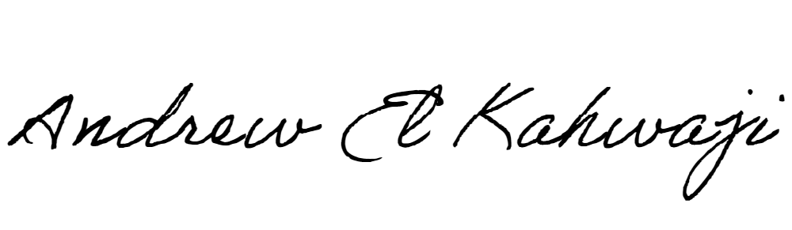

Printed Name _Andrew El Kahwaji_

Date __26/12/2024___

Email __andrew.lifesculptor.coo@gmail.com __

Phone __+961 71 914 378__